

MADHAV INSTITUTE OF TECHNOLOGY & SCIENCE, GWALIOR
(Deemed University)
(Declared Under Distinct Category by Ministry of
Education, Government of India)
NAAC Accredited with A++ Grade
Department of Electronics Engineering
Dr. Mukesh Mishra
Submitted to
Submitted by
Krishna Dubey ( BTEL25O1060 )
Mayank Singh Kushwah (BTEL25O1068)
Electronics Engineering
Macro Project
on

Development of an Automatic Classroom Bell System using RTC and Arduino
DECLARATION
I hereby declare that the project work entitled “Development of an Automatic Classroom Bell System using RTC and Arduino” submitted to the Madhav Institute of Technology & Science Gwalior, is a record of an original work done by Krishna Dubey & Mayank Singh Kushwah under the guidance of Dr. Mukesh Mishra, Department of Electronics Engineering.
The results embodied in this thesis have not been submitted to any other University or Institute for the award of any degree or diploma.

Krishna Dubey
(BTEL25O1060)

Mayank Singh Kushwah
(BTEL25O1068)

Date:
Place: Gwalior

CERTIFICATE
This is to certify that the Macro Project report entitled “Development of an Automatic Classroom Bell System using RTC and Arduino” submitted by Krishna Dubey & Mayank Singh Kushwah has been carried out under the guidance of Dr. Mukesh Mishra, Department of Electronics Engineering, Madhav institute of technology & Science, Gwalior. The Project report is approved for submission requirement for Macro Project in 3rd semester in Electronics Engineering, from Madhav Institute of Technology & Science, Gwalior (M.P.)

Submitted To:
Dr. Mukesh Mishra

Signature : _____________
[Department Of Electronics Engineering]
INDEX
S. No. | Topic | Page No.
1. | Objective | 5
2. | Abstract | 5
3. | Apparatus Required | 5
4. | Theory | 6
5. | Connection diagram and Flowchart | 7
6. | Procedure | 8-10
7. | Result | 11
8. | Applications | 12
9. | Conclusion | 12
10. | References | 12

OBJECTIVE :-
Development of an Automatic Classroom Bell System using RTC and Arduino.
ABSTRACT :-
The project titled “Development of an Automatic Classroom Bell System using RTC and Arduino” The Automatic Classroom Bell System using RTC and Arduino is designed to automate the ringing of bells in schools, colleges and other educational institutions. In the traditional system, a person is required to operate the bell manually at the beginning and end of each class, during lunch breaks and at the end of the school day. This process requires continuous human involvement and may sometimes cause delays. To overcome this problem, an automatic bell system is developed using an Arduino Uno and a Real-Time Clock (RTC) module. The RTC module keeps track of the current time and sends the time information to the Arduino. The Arduino compares the current time with the predefined bell schedule stored in its program. Whenever the current time matches the programmed time, the Arduino activates , which switches ON the electric bell for a specified duration. After that, the relay automatically switches OFF the bell. This system reduces manual effort, saves time and provides accurate and reliable operation.
APPARATUS REQUIRED :-
COMPONENTS | QUANTITY
Battery 9v | 1
Arduino | 1
Battery-Arduino Connector | 1
Breadboard | 1
Buzzer | 1
RTC-Module DS3231 | 1
LED Display 16*2 | 1
Push Button | 3
Jumper wires | 15

THEORY :-
The Basic Alarm Bell project is based on the concept of real-time system monitoring using programming techniques. The main principle involves tracking the current system time and comparing it with a user-defined alarm time for bell. The time library is used to obtain and manage the current time from the system clock. The program runs continuously using a loop to check the time at regular intervals. Conditional statements are used to compare the current time with the set alarm time. When both times match, the program executes a command to trigger a sound alert. The sound library is used to generate an audible alarm notification. This project demonstrates event-driven programming, where an action occurs when a specific condition is satisfied. It also applies basic programming concepts such as loops, conditions, and user input handling. Overall, the system works by continuously monitoring time and responding when the preset condition is met.

Working of R2C Module :-
The DS3231 is a real-time clock IC that keeps track of time using a built-in 32.768 kHz temperature-compensated crystal oscillator (TCXO). The oscillator generates precise pulses, which are internally divided by a counter chain to update the seconds, minutes, hours, day, date, month and year. These values are stored in the IC’s internal registers in BCD (Binary Coded Decimal) format. The DS3231 communicates with the Arduino through the I²C protocol using the SDA and SCL lines, with the default address 0x68. This lets the microcontroller read the current time from the registers or write (set) a new time into them. The module also has a battery backup input, for which a CR2032 coin cell is used. When the main power supply is switched off, the IC automatically switches to the battery, so the clock keeps running and the time is not reset. Because of its high accuracy of about ±2 ppm and its battery backup, the DS3231 is reliable for digital clocks, alarms, data loggers and, in this project, the automatic classroom bell system.

Working of the Development of an Automatic Classroom Bell System using RTC and Arduino
A basic alarm Bell program works by taking a user-defined alarm time (in HH:MM:SS format) and continuously checking the system’s current time using the time library in a loop; it compares the current time with the set alarm time every second, and when both match, the program triggers an alert by playing a beep sound with the help of buzzer for few seconds programmed according to code , thereby simulating the functioning of a real alarm bell that rings at a specific scheduled time.

CONNECTION DIAGRAM :-
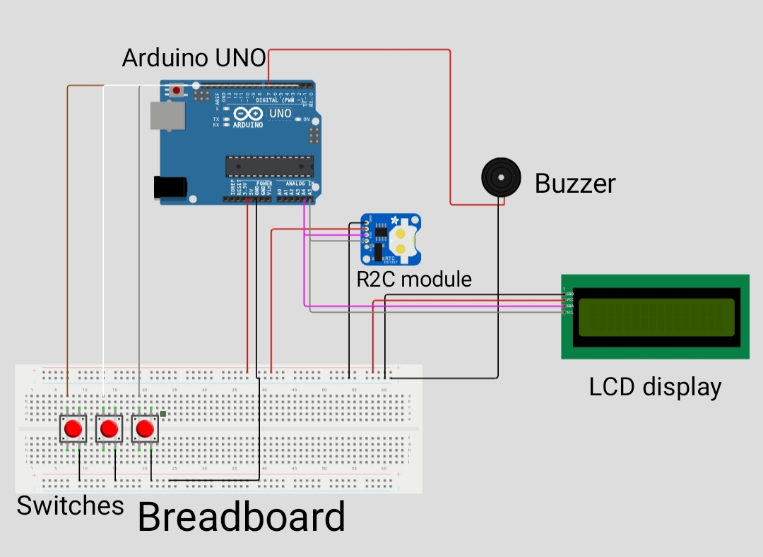
Fig 1.1: Connection diagram of Arduino uno based alarm bell system showing Arduino uno, R2C module, LCD display, buzzer, breadboard and switches.

FLOWCHART :-
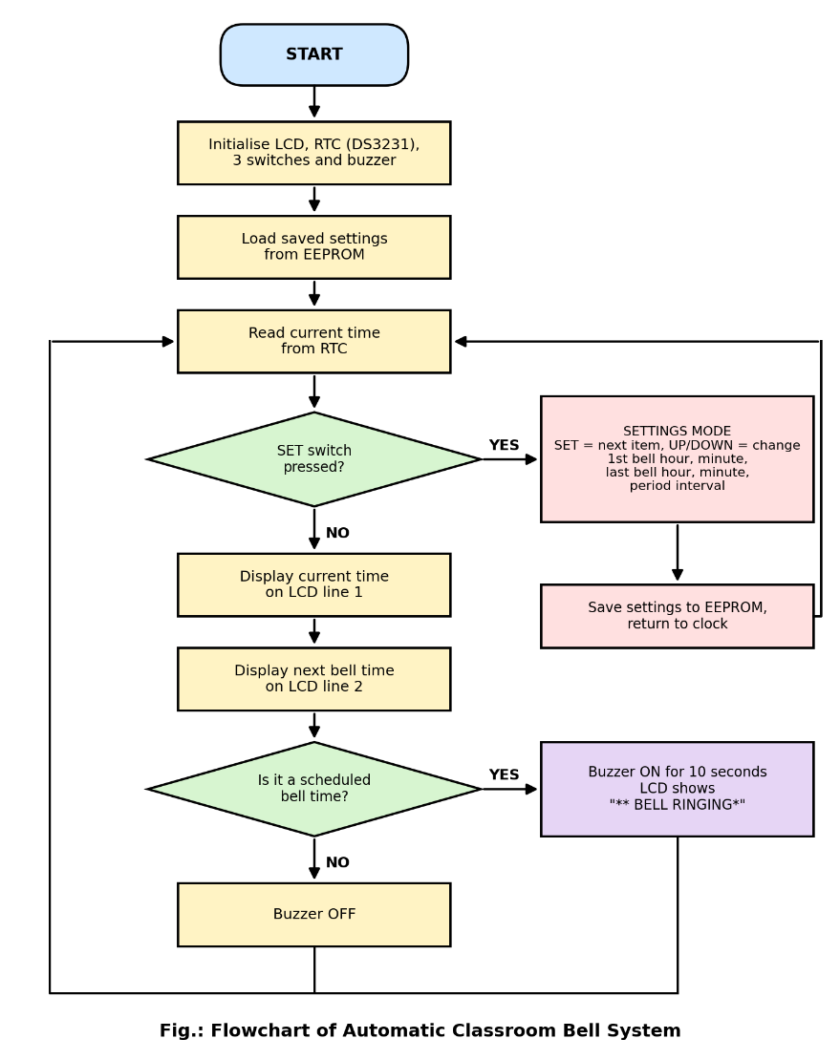

PROCEDURE:-
Step 1 : Connect the RTC DS1307 Module
- SCL pin of DS3231 → Arduino A5
- SDA pin of DS3231 → Arduino A4
- VCC pin of DS3231 → Arduino 5V
- GND pin of DS3231 → Arduino GND
Step 2 : Connect the LCD Display (via I2C Module)
- SCL pin of LCD I2C → Arduino SCL (same line as A5)
- SDA pin of LCD I2C → Arduino SDA (same line as A4)
- VCC pin of LCD I2C → Arduino 5V
- GND pin of LCD I2C → Arduino GND
Step 3 : Connect the Buzzer
- Red wire (Positive) → Arduino Digital Pin 7
- Black wire (Negative / GND) → Arduino GND
The buzzer triggers when Arduino sends a HIGH signal on Pin 7 at the moment alarm time matches current time.
Step 4 : Connect the 3 Push Switches
Each switch is a 4-pin type — one pair of pins connects to GND, the other pair to the Arduino digital pin. Use INPUT_PULLUP in code; no external resistors needed.
- Switch 1 (LEFT / Decrease) — One side → Arduino GND | Other side → Digital Pin 4
- Switch 2 (MIDDLE / Set/Confirm) — One side → Arduino GND | Other side → Digital Pin 2
- Switch 3 (RIGHT / Increase) — One side → Arduino GND | Other side → Digital Pin 3
Step 5 : Power Supply
- Connect Arduino UNO to a 5V USB supply or a 9V battery via the DC barrel jack.
Step 6: Normal State → Enter Settings Mode
- On power-up the system enters Normal State. The LCD continuously shows the current running time (HH:MM:SS) fetched from the DS3231.
- Press the MIDDLE Switch (Pin 2) once to enter Settings Mode.
- The display shifts to the first setting, “1st Bell: HOUR”, with its value on line 2, ready to be edited.
Step 7: Set the 1st Bell (Hour, then Minute)
- Setting hours:
- Press RIGHT Switch (Pin 3) and the hour increases (0 to 23).
- Press LEFT Switch (Pin 4) and the hour decreases.
- Setting minutes:
- Press MIDDLE Switch (Pin 2) once more and the screen changes to “1st Bell: MIN”.
- Press RIGHT (Pin 3) to increase and LEFT (Pin 4) to decrease (0 to 59).
Step 8: Set the Last Bell and the Period Interval
- Press MIDDLE (Pin 2) again to open “Last Bell: HOUR”. Set it with RIGHT and LEFT, then press MIDDLE to move on to “Last Bell: MIN” and set the minutes the same way.
- Press MIDDLE once more to open “Period Interval”.
- Use RIGHT to increase and LEFT to decrease the interval in minutes (1 to 180). Example: 45 min.
Step 9: Confirm and Save, LCD Now Shows Both Times
- Press MIDDLE (Pin 2) once more to confirm. All the settings are saved in the Arduino’s EEPROM, so they are not lost after a power cut.
- The system exits settings mode and returns to the normal display.
- The LCD now shows two lines together. For example:
- Line 1: Time: 09:45:30 (current time, updated every second from the DS3231)
- Line 2: Next: 10:15 (next bell time)
Step 10: Background Comparison (Internal Microcontroller Process)
- The Arduino runs a continuous loop() that reads the time from the DS3231 and compares it with the bell schedule on every cycle.
- The bell schedule is made from the 1st bell, last bell and interval. A bell is due when the current time is between the 1st and last bell, the minutes since the 1st bell divide exactly by the interval, and the seconds are less than 10.
- Internal logic:
if (now Min >= first && now Min <= last && (now Min - first) % interval == 0 && second < 10) {buzzer ON;}
- This comparison runs silently in the background while the clock display keeps updating, and the “Next” line moves to the following bell after each ring.
Step 11: Result, Buzzer Rings for 10 Seconds
- When the time matches a bell time, the Arduino sends a HIGH signal to Digital Pin 7.
- The buzzer rings for 10 seconds and the LCD shows ** BELL RINGING*.
- After 10 seconds the signal goes LOW, the buzzer stops, and the system waits for the next bell. The cycle repeats automatically from the 1st bell to the last bell every day.

PROJECT IMAGE

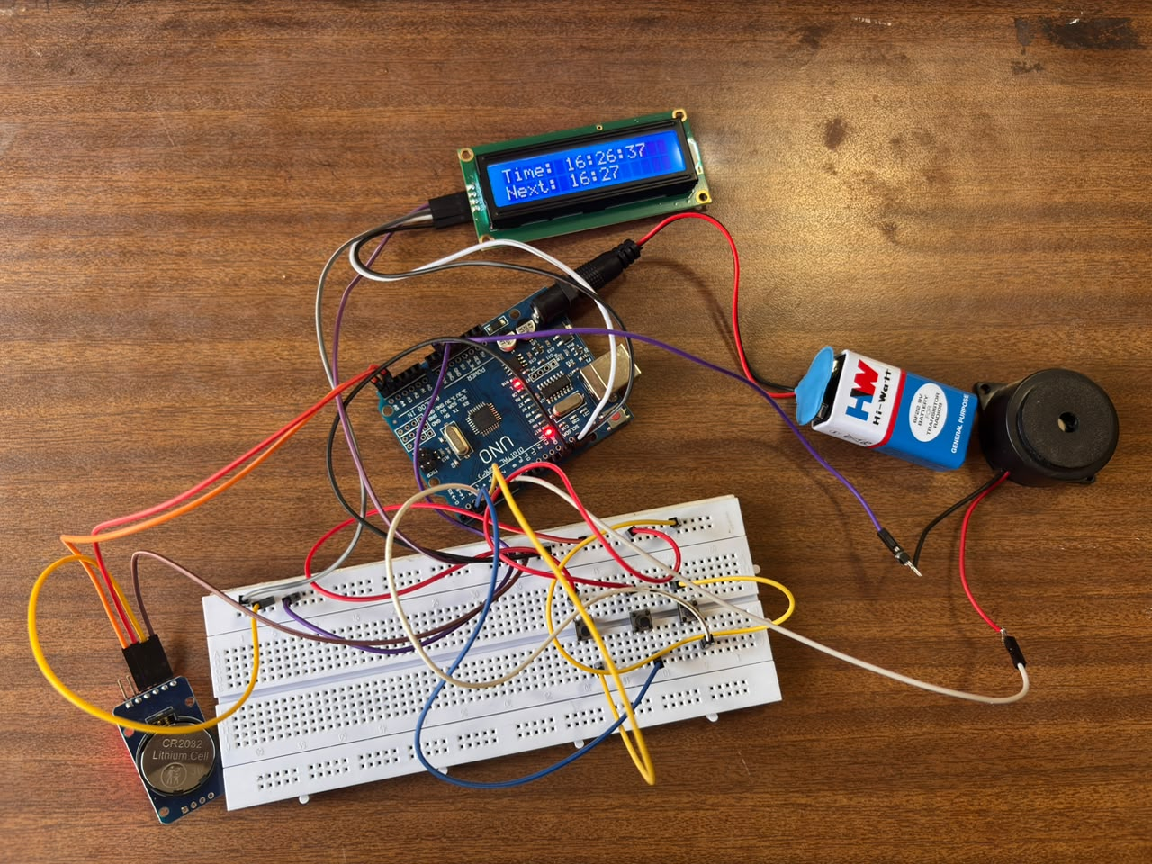
Fig 3: Project image demonstrating connection and real time monitoring .

RESULT :-
The Automatic Classroom Bell System was successfully implemented using the Arduino, the DS3231 RTC module and a buzzer. The system accepted the user-defined 1st bell time, last bell time and period interval through the three switches, and stored them in the EEPROM so they are kept even after a power cut. It continuously read the current time from the RTC and showed it on the LCD along with the next bell time. The buzzer rang for 10 seconds at every scheduled bell time, from the 1st bell to the last bell, and stayed silent at all other times. The project demonstrated correct time comparison, accurate timekeeping, and proper buzzer output, and so achieved the objective of automatically ringing the classroom bell without any manual effort.

APPLICATIONS:
- Schools and Colleges: Rings the bell automatically at the start and end of every period, break and lunch, so the timetable is followed exactly without a person ringing it.
- Examination Halls: Gives the start, warning and end signals during exams at fixed times without any delay or mistake.
- Coaching Institutes and Training Centres: Manages batch timings, class changes and break intervals when many batches run in one day.
- Factories and Industries: Signals shift changes, lunch breaks and tea breaks to workers on time.
- Hostels, Hospitals and Offices: Gives fixed-time alerts for meal times, visiting hours, lights-out and work start and end.

CONCLUSION :-
The Automatic Classroom Bell System was successfully designed and implemented using an Arduino, a DS3231 RTC module, a 16x2 I2C LCD, a buzzer and three switches. The system effectively allows users to set the 1st bell time, last bell time and period interval, and provides an alert through the buzzer for 10 seconds whenever a scheduled bell time is reached.
This project helped in understanding real-time clock interfacing, I2C communication, EEPROM data storage, and buzzer control in a simple embedded application. It also improved problem-solving and logical thinking skills.
Overall, the project demonstrates how basic embedded programming concepts can be applied to create a useful solution for schools and colleges. Future improvements can include adding features like different bell timings for different days, a holiday and Sunday skip option, different ring patterns for different events, and wireless control through Bluetooth or Wi-Fi.

REFERENCES:
- Arduino IDE Documentation https://docs.arduino.cc/software/ide/
- Circuit Digest, "DIY Arduino Based Digital Alarm bell using RTC DS1307 & 16x2 LCD", circuitdigest.com, 2020. https://circuitdigest.com/microcontroller-projects/arduino-alarm-clock
- Instructables, "Arduino Real Time Clock Tutorial Using DS1307", instructables.com, 2021.https://www.instructables.com/Arduino-Real-Time-Clock-Tutorial-Using-DS3231.

